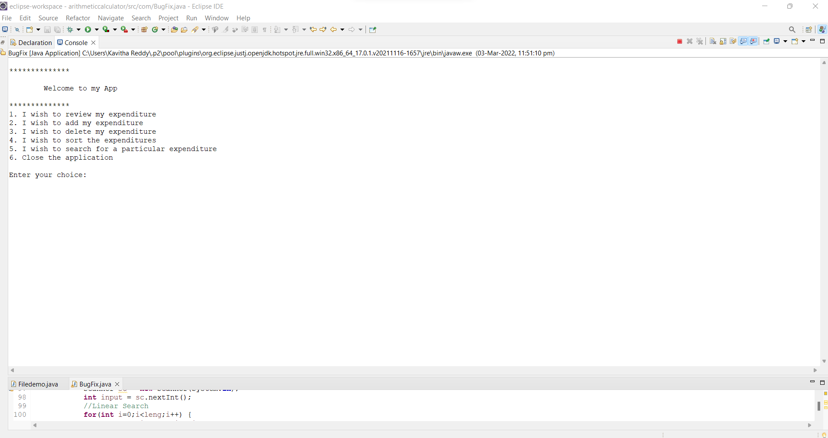

After running of application we get this page first here we have select our choice

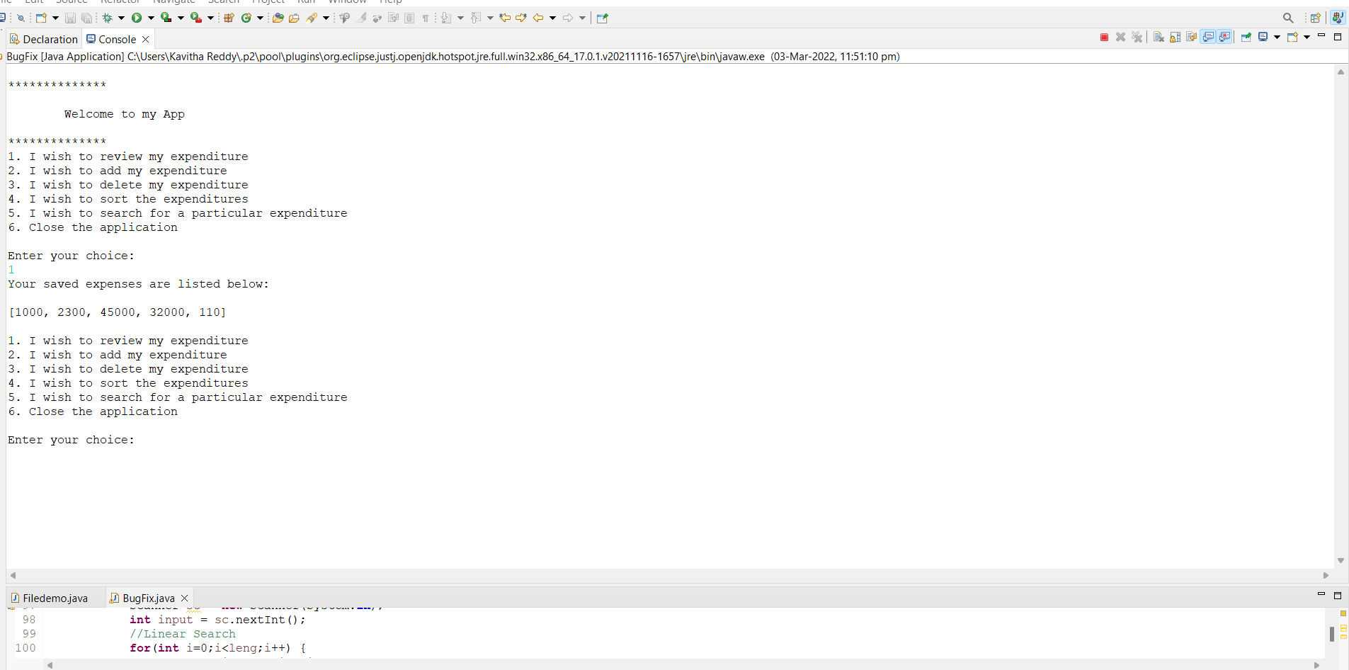

If we select 1 means it will display this page

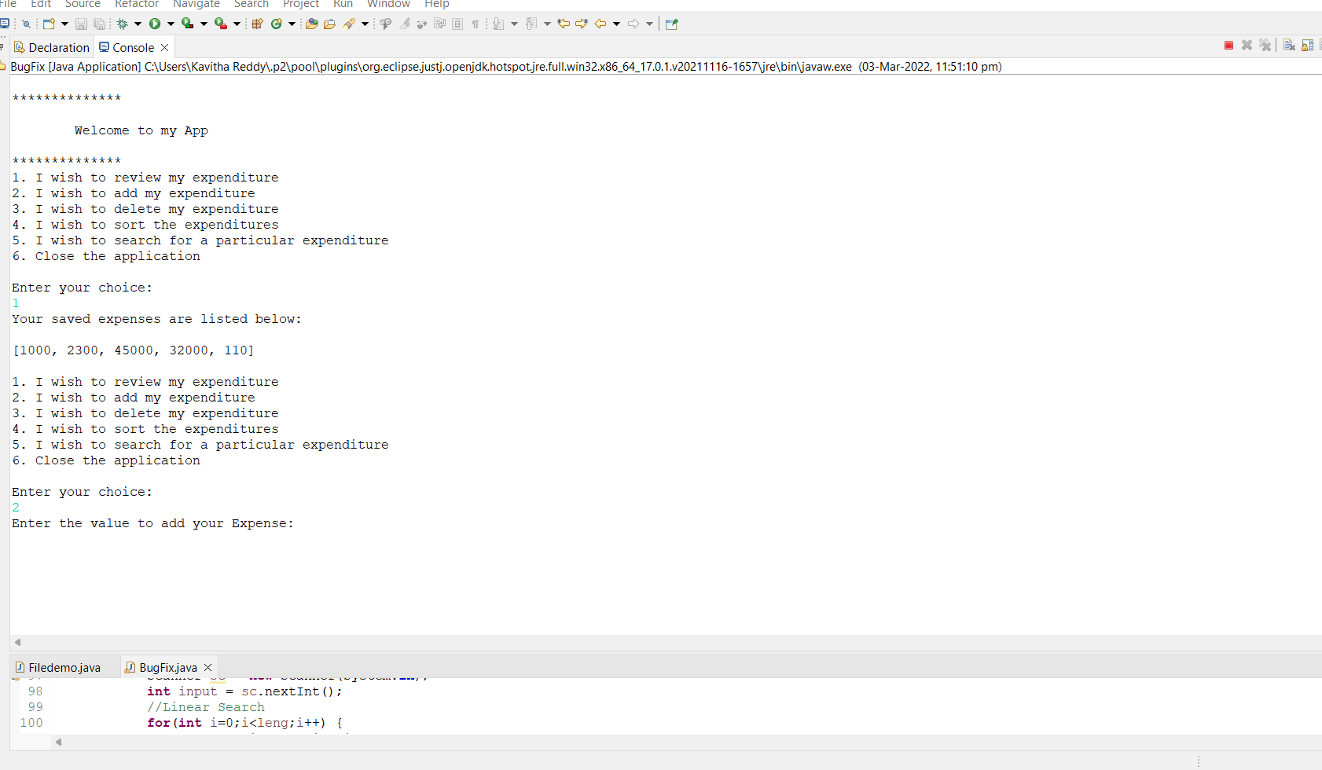

Here it is showing our expenditure and also it is asking to select another option

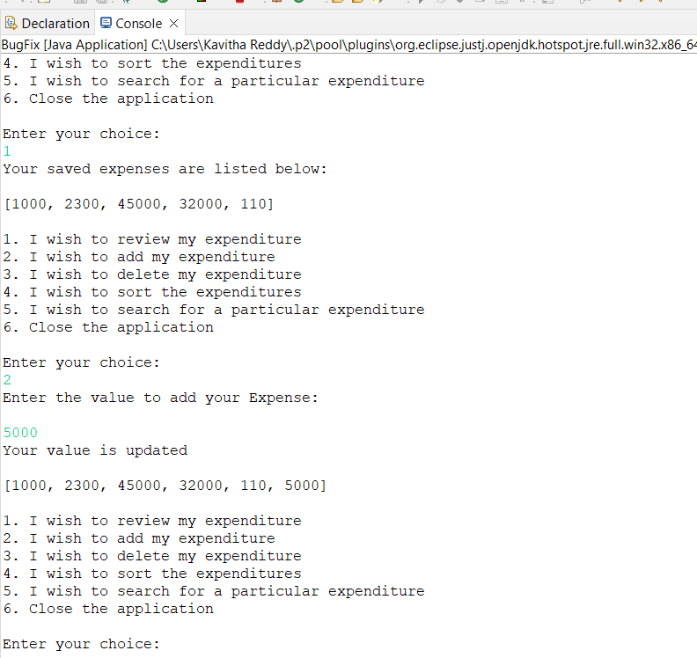

In second option we can add our expenditure

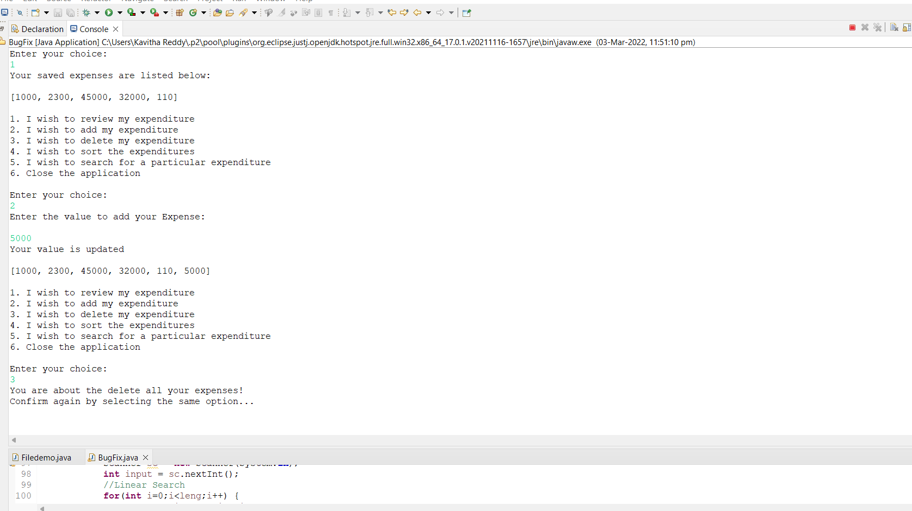

Here I selected 3rd option to delete my expenditure

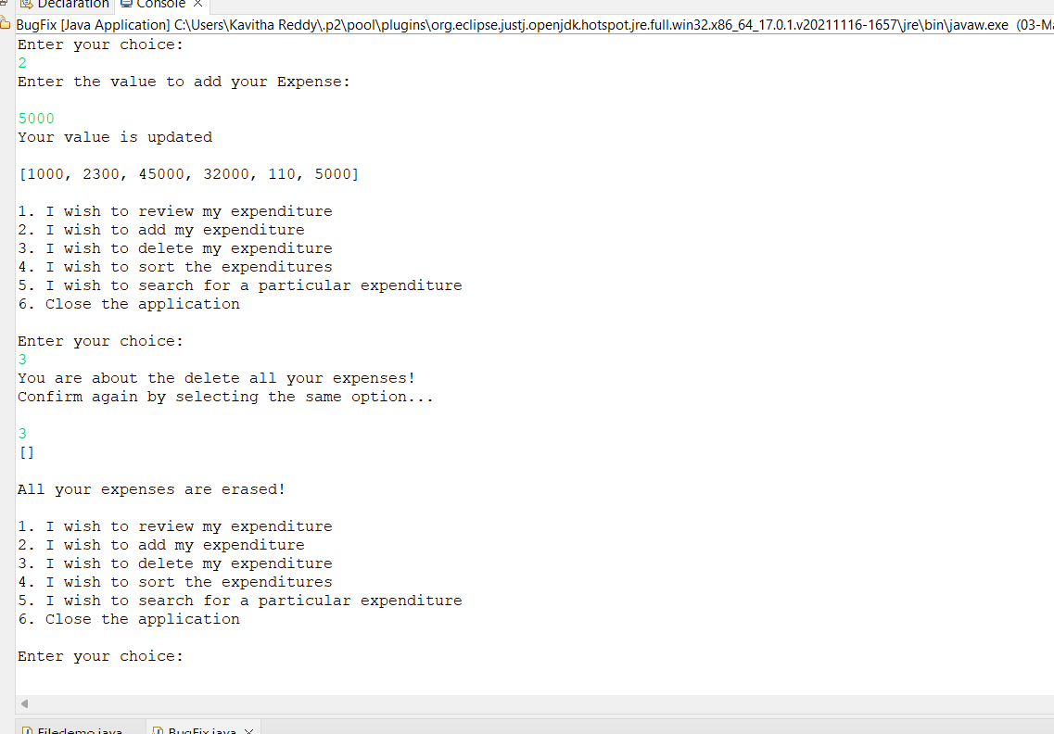

Here all our expenditures are deleted and also asking to select next option

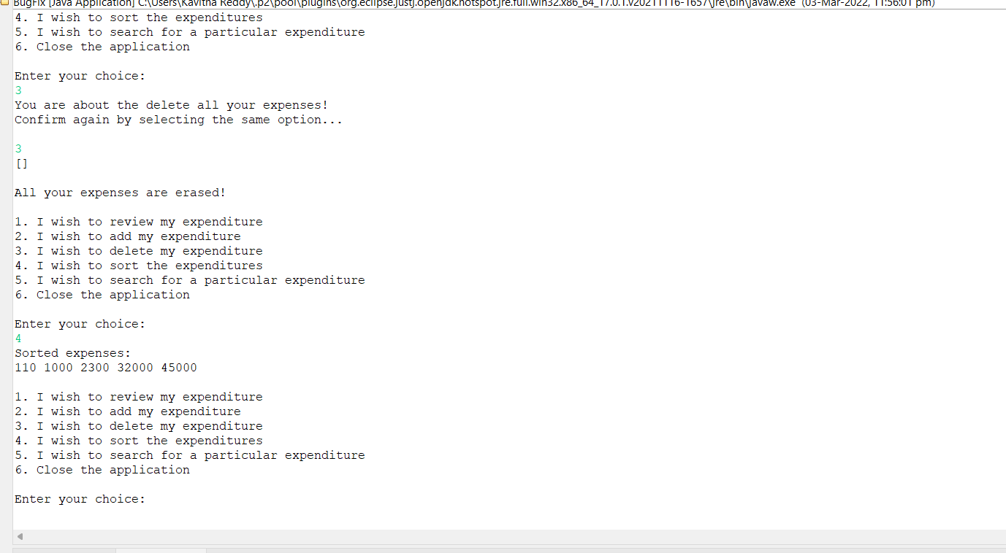

In 4th option we can sort our expenditures

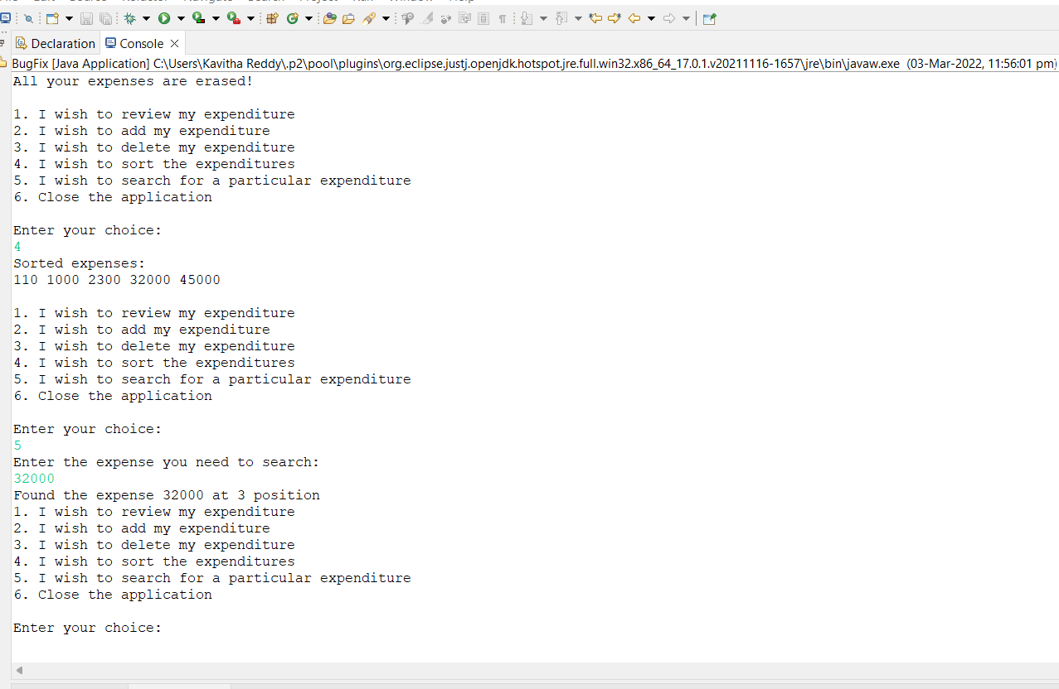

In 5th option we can search our particular expenditure

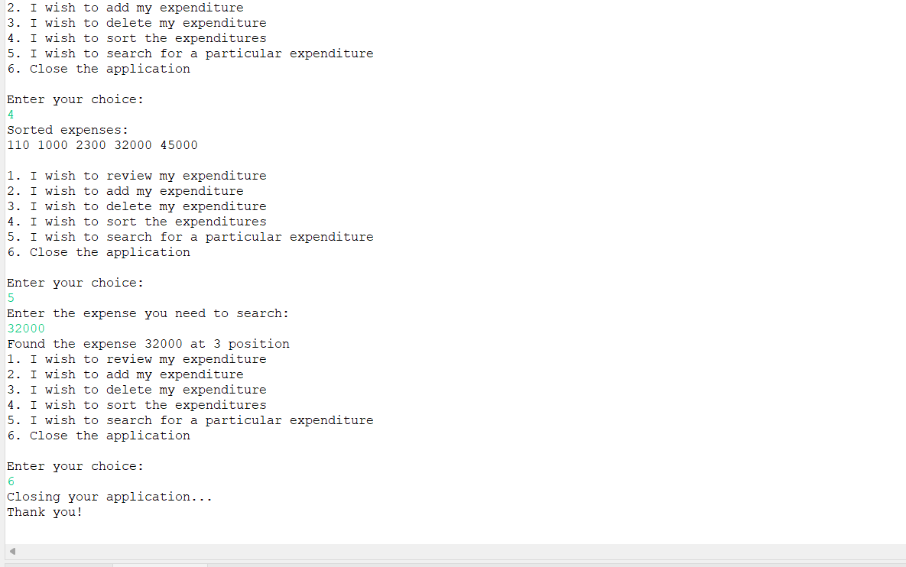

It displayed one message that my searched expenditure is found in particular position at last I selected 6th option to close my application.